Experiment 4
AIM: To implement aggregate functions in SQL. THEORY:
Query
create table student__55( roll_no INT PRIMARY KEY, physics INT, chemistry INT, mathematics INT);
INSERT INTO student__55 VALUES(1, 18, 15, 40);
INSERT INTO student__55 values(2, 20, 22, 45);
INSERT INTO student__55 values(3, 10, 14, 30);
INSERT INTO student__55 values (4, 16, 11, 20);
INSERT INTO student__55 values (5, 25, 20, 50);
INSERT INTO student__55 values(6, 12, 12, 25);
INSERT INTO student__55 values(7, 14, 18, 35);
INSERT INTO student__55 values(8, 8, 10, 15);
INSERT INTO student__55 values(9, 22, 23, 48);
INSERT INTO student__55 values(10, 13, 16, 28);
select * from student__55;
output
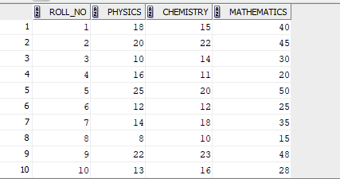
- Find the class average for the subject ‘Physics’
SELECT AVG(physics) AS avg_physics FROM student__55;
Output:
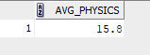
2: Find the lowest marks for chemistry(To be displayed as lowest_mark_chemistry)
SELECT MIN(chemistry) AS lowest_mark_chemistry FROM student__55;
Output:
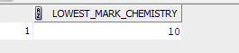
3: 2. Find the highest marks for mathematics (To be displayed as highest_marks_maths).
SELECT MAX(mathematics) AS highest_marks_maths FROM student__55;
Output:
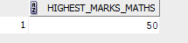
4: Find the total number of students who have got a ‘pass’ in physics.
select count(*) AS pass_physics from student__55 where physics >=12;
Output:
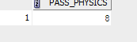
5: . Generate the list of students who have passed in all the subjects
select * from student__55 where status = 'pass';

output:
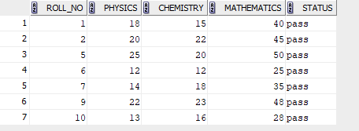
6: Generate a rank list for the class. Indicate Pass/Fail. Ranking based on total marks obtained by the students
select roll_no, (physics + chemistry + mathematics) as TOTAL_MARKS,status from student__55;
output:
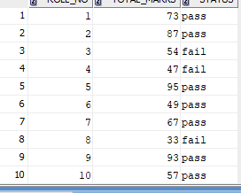
7: Find pass percentage of the class for mathematics
select avg (mathematics)as avg_maths from student__55 where status='pass';
output:
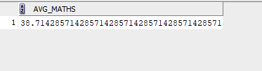

8: Find the overall pass percentage for all classes.
SELECT AVG( mathematics+chemistry+physics) AS avg_of_pass from student__55 where status ='pass
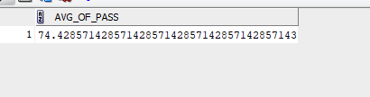
9: SELECT COUNT(*) AS total_pass_students FROM student__55 WHERE UPPER(status) = 'PASS'
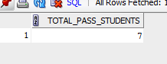
10: SELECT AVG(physics + chemistry + mathematics) AS class_average FROM student__55;
Output:
